**ENTITY RELATIOSHIP DIAGRAMS**

**Cardinality and ordinality :** Cardinality refers to the maximum number of times an instance in one entity can relate to instances of another entity. Ordinality, on the other hand, is the minimum number of times an instance in one entity can be associated with an instance in the related entity. Cardinality and ordinality are shown by the styling of a line and its endpoint, according to the chosen notation style.

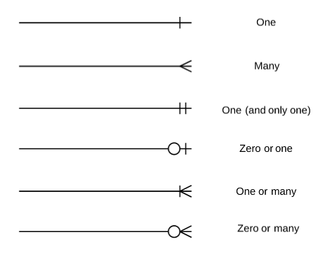

Primary Keys : Primary keys are an attribute or combination of attributes that uniquely identifies one and only one instance of an entity.

Foreign Keys : Foreign keys are created any time an attribute relates to another entity in a one-to-one or one-to-many relationship.

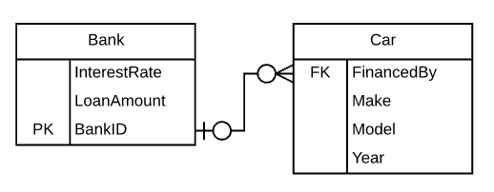  
Each car can only be financed by one bank, therefore the primary key BankId from the Bank table is used as the foreign key FinancedBy in the Car table.  This BankID is able to be used as the foreign key for multiple cars.

1. **ER Diagram 1**

The local city youth league needs a database system to help track children who sign up to play soccer. Data needs to be kept on each team, the children who will play on each team, and their parents. Also, data needs to be kept on the coaches for each team. Draw a data model with the entities and attributes described here.

Entities required: Team, Player, Coach, and Parent

Attributes required:

Team: Team ID number, Team name, and Team colors

Player: Player ID number, Player first name, Player last name, and Player age

Coach: Coach ID number, Coach first name, Coach last name, and Coach home phone number

Parent: Parent ID number, Parent last name, Parent first name, Home phone number, and Home address (Street, City, State, and Zip code)

The following relationships must be defined:

1. Team is related to Player.

2. Team is related to Coach.

3. Player is related to Parent.

Connectivity and participations are defined as follows:

* A Team may or may not have a Player.
* A Player must have a Team.
* A Team may have many Players.
* A Player has only one Team.
* A Team may or may not have a Coach.
* A Coach must have a Team.
* A Team may have many Coaches.
* A Coach has only one Team.
* A Player must have a Parent.
* A Parent must have a Player.
* A Player may have many Parents.
* A Parent may have many Players.

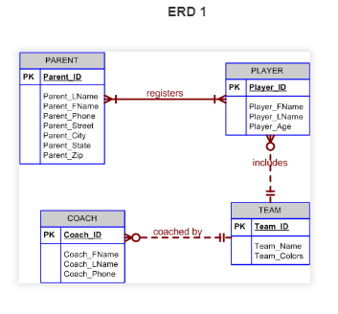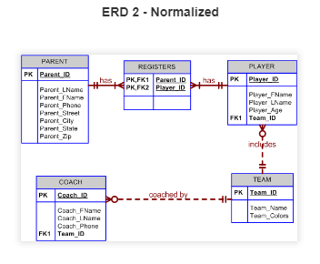

1. **ER : Diagram 2**

Draw an **ER diagram** for the given scenario of buying an article.

Entities: Article, Source, Order, Copyright Agency, Country, Buyer

Attributes:

Article: Title(PK),authors, pdf file, fee

Source: Title(PK), publisher,issue,date, pages

Order: Order number(PK),total payment, date, tax status

Copyright Agency: name, address

Country: copyright from, taxrate

Buyer: name, address, email(PK), billing info

Following relationships are to be set:

a. Article is published in source. Many articles can be published in many sources.

b. Buyer places order. He can place zero or more orders.

c. Orders deliver articles. One article can be delivered in many orders and one order can deliver many articles as well.

d. Source pays fees to Copyright agency for every article published.

e. Every country has a single source of publication.

**Solution:**

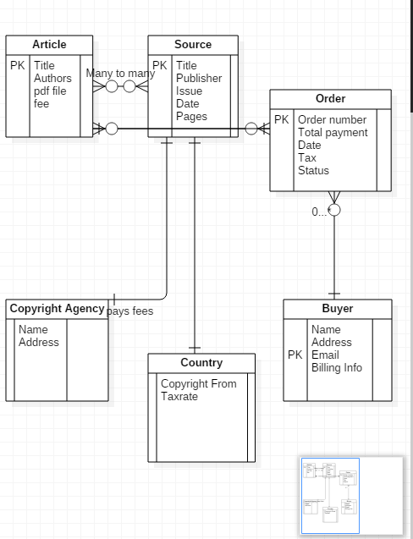

**ER Diagram 3**

Create an ERD using the following requirements:

* An INVOICE is written by a SALESREP. Each sales representative can write many invoices, but each invoice is written by a single sales representative.
* The INVOICE is written for a single CUSTOMER. However, each customer can have many invoices.
* An INVOICE can include many detail lines (LINE), each of which describes one product bought by the customer.
* The product information is stored in a PRODUCT entity.
* The product’s vendor information is found in a VENDOR entity.

**Solution:**

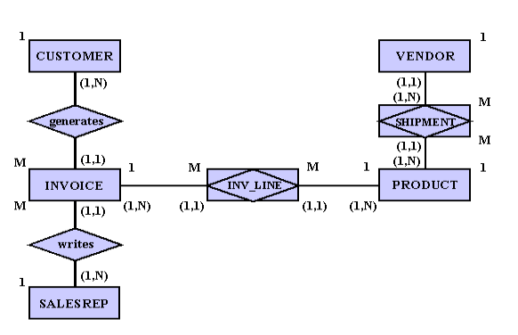

**ER : Diagram 4**

Suppose you are given the following requirements for a simple database for the

National Hockey League (NHL):

• the NHL has many teams,

• each team has a name, a city, a coach, a captain, and a set of players,

• each player belongs to only one team,

• each player has a name, a position (such as left wing or goalie), a skill level, and

a set of injury records,

• a team captain is also a player,

• a game is played between two teams (referred to as host_team and guest_team)

and has a date (such as May 11th, 1999) and a score (such as 4 to 2).

Construct a clean and concise ER diagram for the NHL database.

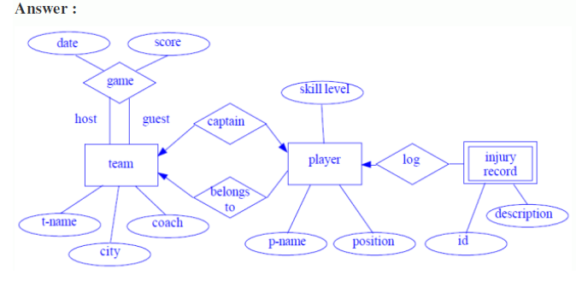

**ER : Diagram 5**

A university registrar’s office maintains data about the following entities:

1. courses, including number, title, credits, syllabus, and prerequisites;

2. course offerings, including course number, year, semester, section number, instructor(s), timings, and classroom;

3. students, including student-id, name, and program;

4. Instructors, including identification number, name, department, and phone number. Further, the enrollment of students in courses and grades awarded to students in each course they are enrolled for must be appropriately modeled.

**Construct an E-R diagram for the registrar’s office. Document all assumptions that you make about the mapping constraints.**

**Solution:**

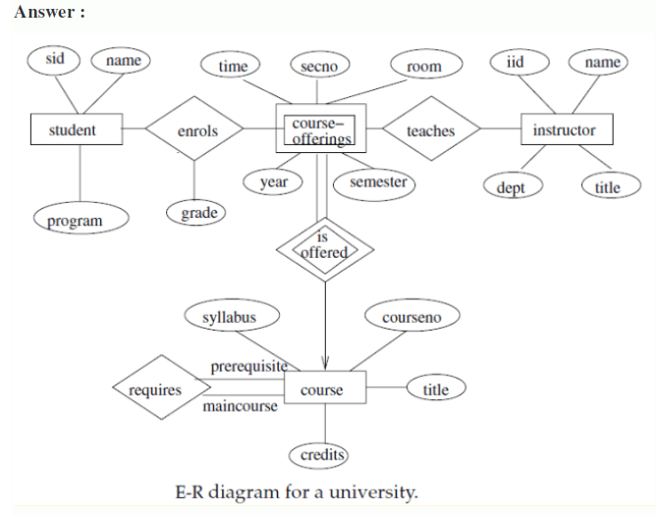

**E-R Model Case Studies**

**For reference purpose :**

1. **(a)** Construct an E-R diagram for a car-insurance company whose customers own one or more cars each. Each car has associated with it zero to any number of recorded accidents.

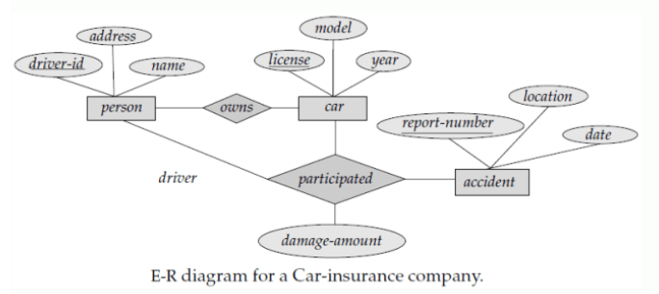

**(b)** Construct appropriate tables for the above ER Diagram ?

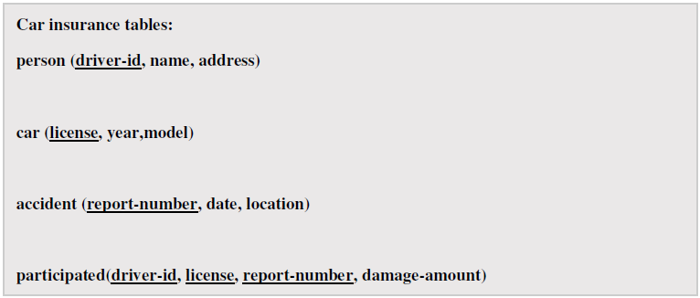

**7.**

**(a)** Construct an E-R diagram for a hospital with a set of patients and a set of medical doctors. Associate with each patient a log of the various tests and examinations conducted.

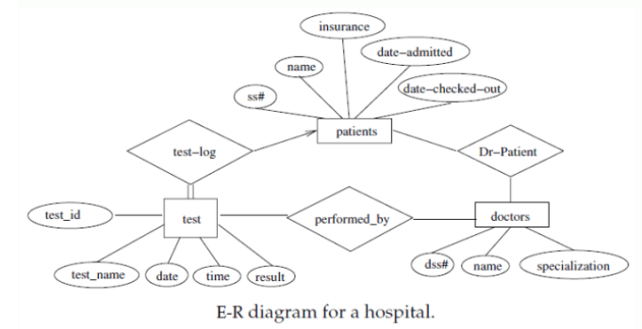

**(b)** Construct appropriate tables for the above ER Diagram :

**Patient(SS#, name, insurance)**

**Physician ( name, specialization)**

**Test-log( SS#, test-name, date, time)**

**Doctor-patient (physician-name, SS#)**

**Patient-history(SS#, test-name, date)**

**8:** Consider a database used to record the marks that students get in different exams of different course offerings.

1. Construct an E-R diagram that models exams as entities, and uses a ternary relationship, for the above database.

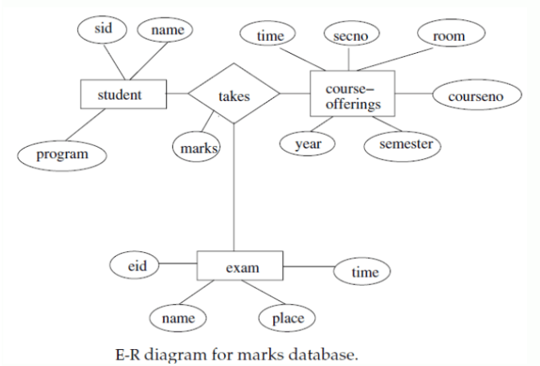

**b)** Construct an alternative E-R diagram that uses only a binary relationship between students and course-offerings. Make sure that only one relationship exists between a particular student and course-offering pair, yet you can represent the marks that a student gets in different exams of a course offering.

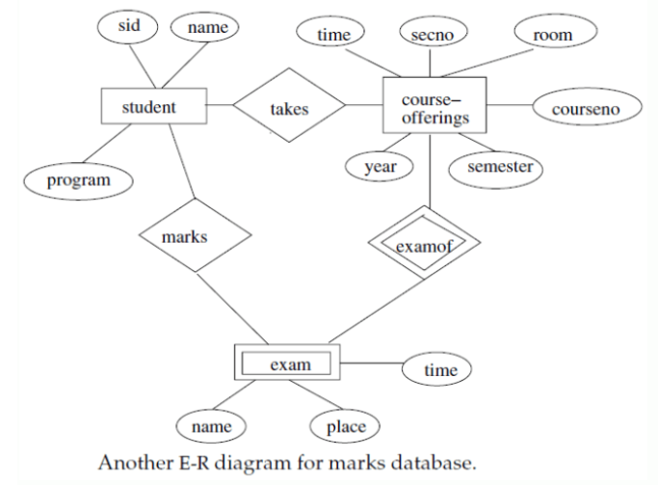

**9:** Design an E-R diagram for keeping track of the exploits of your favorite sports team. You should store the matches played, the scores in each match, the players in each match and individual player statistics for each match. Summary statistics should be modeled as derived attributes.

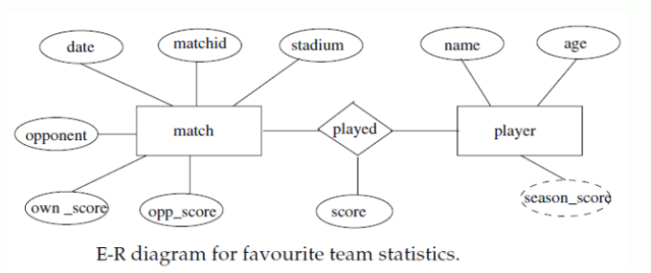

**10 :**Extend the E-R diagram of the previous question to track the same information for all teams in a league.

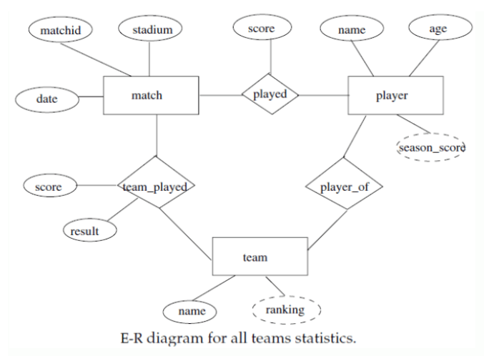

**11 :** Draw the E-R diagram which models an online bookstore.

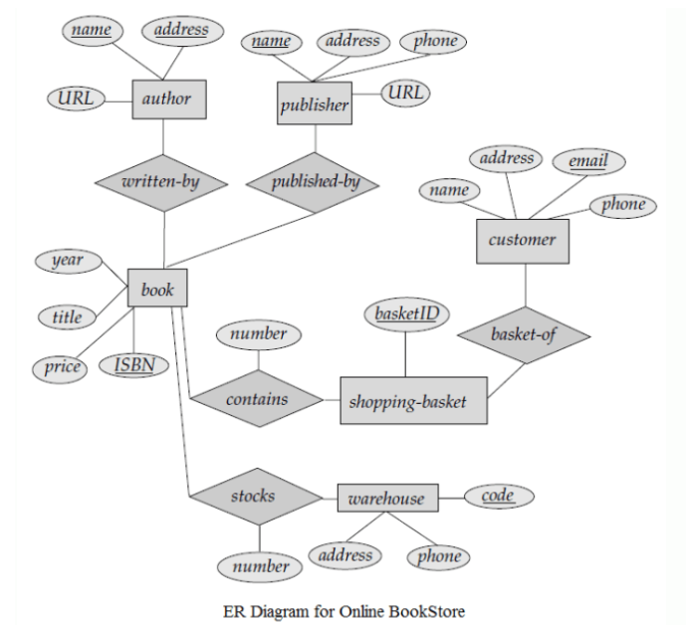

**12 :** Consider a university database for the scheduling of classrooms for -final exams. This database could be modeled as the single entity set exam, with attributes course-name, section number, room-number, and time. Alternatively, one or more additional entity sets could be defined, along with relationship sets to replace some of the attributes of the exam entity set, as

•  course with attributes name, department, and c-number

• section with attributes s-number and enrollment, and dependent as a weak entity set on course

•  room with attributes r-number, capacity, and building

Show an E-R diagram illustrating the use of all three additional entity sets listed

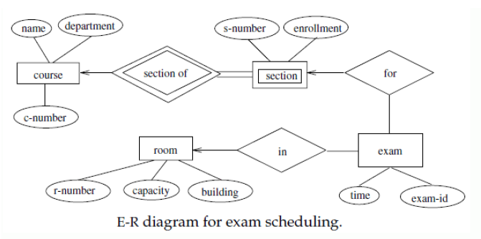

**13 : Construct an ER Diagram for Company having following details :**

•  Company organized into DEPARTMENT. Each department has unique name

and a particular employee who manages the department. Start date for the manager is

recorded. Department may have several locations.

•  A department controls a number of PROJECT. Projects have a unique name,

number and a single location.

•  Company’s EMPLOYEE name, ssno, address, salary, sex and birth date

are recorded. An employee is assigned to one department, but may work for several

projects (not necessarily controlled by her dept). Number of

hours/week an employee works on each project is recorded; The immediate supervisor

for the employee.

•  Employee’s DEPENDENT are tracked for health insurance purposes (dependent

name, birthdate, relationship to employee).

